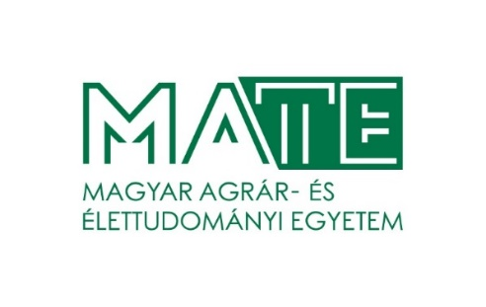
HUNGARIAN UNIVERSITY OF AGRICULTURE AND LIFE SCIENCES
RULES OF ORGANISATION AND OPERATION

III. REQUIREMENTS FOR STUDENTS

III.1. RULES OF EDUCATION AND EXAMINATION

Appendix 7:

III.1.7F. REQUEST FOR ENCRYPTION OF DIPLOMA WORK/THESIS

March 2021.

REQUEST FOR ENCRYPTION

Signed below ___________________ (Neptun-ID: ______________) student at the _____________________ course solicit the encryption of my diploma work/thesis with title: ______________________________ name(s) of supervisor(s): __________________________) in accordance with Section 95§, Paragraph (5) in Rules of Education and Examination at the Hungarian University of Agriculture and Life Sciences (hereafter: REE). I understand, that upon approval of the request, encryption lasts for five years after successful thesis defence in accordance with Section 95§ paragraph (5/c) of REE.

Date: ___________________ (city), _________________ (date)

______________________________
Student

Signed below _________________________ (name and position of company representative), as a representative of ____________________________________ (company name and address) solicit request for encryption of the diploma work/thesis written by ___________________________________ (student name) (Neptun-ID: ______________) with the title of ___________________________________________________ based on data provided by ______________________________________ (company name)

Date: ___________________, _________________

______________________________
Representative

Request for encription is APPROVED/NOT APPROVED.
Justification upon rejection: ___________________________________________________________
_________________________________________________________________________________

Date: ___________________, _________________

______________________________
Course Leader

Choose the relevant and erase the other.
Adittional request of company representative is not compulsory. When it is not requested from the company, this part can be erased from the document.

